



Essay / Assignment Title: Predictive Analytics and Machine Learning Project Report

Programme title:

Name:

Year:

CONTENTS

CONTENTS 2
1. INTRODUCTION 4
Significance of Predictive Analytics and Machine Learning in Decision-Making 4
Business Problem or Scenario Selected for Analysis 4
2. CHAPTER ONE: PROBLEM FORMULATION 5
Customer Churn Prediction 5
Importance of Solving this Problem in a Business Context 5
3. CHAPTER TWO: DATA COLLECTION AND PREPARATION 6
I. Data Collection 6
II. Data Preprocessing Steps 6
Loading the data 6
Exploring the Data 6
III. Handling Missing Values 6
IV. Handling Categorical Variables 7
V. Feature Scaling 7
VI. Feature Selection 7
VII. Data Splitting 8
VIII. Data Transformation 9
4. CHAPTER FOUR: EXPLORATORY DATA ANALYSIS (EDA) 10
Key Findings 10
Insights and Patterns: 10
Visualizations 11
Histogram of Age Distribution 11
Bar Plot of Gender Distribution 11
Pie Chart of Geography Distribution 12
5. CHAPTER FIVE: MODEL SELECTION AND IMPLEMENTATION 14
1. Logistic Regression 14
2. Random Forest Classifier 14
Hyperparameter Tuning and Feature Selection Techniques 15
6. CHAPTER SIX: MODEL EVALUATION 17
Evaluation Metrics 17
Model Evaluation Results 17
Comparison of Model Performance 18
Implications of Model Performance 18
7. CONCLUDING AND RECOMMENDATIONS 19
Summary of Findings 19
Effectiveness of Predictive Analytics Solution 19
Recommendations 19
8. PROJECT REFLECTION 21
Challenges Encountered 21
Lessons Learned 21
Potential Improvements 21
9. BIBLIOGRAPHY 22
APPENDIX (if necessary) 23

Statement of compliance with academic ethics and the avoidance of plagiarism

I honestly declare that this dissertation is entirely my own work and none of its part has been copied from printed or electronic sources, translated from foreign sources and reproduced from essays of other researchers or students. Wherever I have been based on ideas or other people texts I clearly declare it through the good use of references following academic ethics.
(In the case that is proved that part of the essay does not constitute an original work, but a copy of an already published essay or from another source, the student will be expelled permanently from the postgraduate program).

Name and Surname (Capital letters):

.......................................................................................................................................

Date: ........................./........../.........

INTRODUCTION

Significance of Predictive Analytics
Data analysis and its applications through predictive analytics and machine learning are essential for optimal decision-making (Ara, A., Maraj, M.A.A., Rahman, M.A. and Bari, M.H., 2024). They allow the organization to anticipate changes, improve the processes, and make the right decisions based on the analysis of information. While predictive analytics employ historical information in forecasting future trends, machine learning refines these forecasts through new data handling. This combination enhances effectiveness in decision-making, otherwise, offers a competitive advantage (Bharadiya, J.P., 2023).

Business Problem
There is customer attrition, which means the firm is unable to retain the customers and loses out on the revenue it could have earned from these clients, this also has high costs of acquiring a customer. In order to counter this, company has planned to build up a customer churn prediction model for its commercial use with the help of predictive analytics and machine learning. Hence, this model will categorize customers who are potential to churn out based on the past behavior, age, gender, and frequency of purchase. The objective is to apply selective tactics of encouraging customer loyalty in order to have less customer attrition rates, to show how practical predictive analysis is useful in helping enforce customer retention and organizational efficiency.

CHAPTER ONE: PROBLEM FORMULATION

Customer Churn Prediction
In this context, the specific problem in this predictive analysis is to predict if a bank customer is going to churn or not (Dias, J., Godinho, P. and Torres, P., 2020). Cham: Springer International Publishing.). There are different features about customers within the dataset including the CustomerID, surname, credit score, and other related factors. The question is how to build a predictive model that helps determine which customers are likely to churn. With this information the bank will be in a position to put in place efficient retention strategies and mitigate the high levels of customer churn.

Significance in Business Context
Managing customer churn represents one of the most significant challenges for the bank (Singh, P.P., Anik, F.I., Senapati, R., Sinha, A., Sakib, N. and Hossain, E., 2024). This is because acquiring new customers is costly compared to nurturing the existing ones, and therefore retaining customers is economical. This way the bank gets a clear understanding of its customer base and can work out which customers are likely to desert it and then take relevant actions that will enhance customer loyalty. This may be in the form of offers, better services or even communication channels that suit their taste.

Furthermore, decreasing churn can be seen that has a positive effect on the bank’s profit. Customer retention is important because it guarantees the continuity of revenues, consolidates the positions of the bank in the financial market (Park, W. and Ahn, H., 2022). Furthermore, identification of factors driving churn may help the bank gather useful information on how to improve its business strategy. Hence, fixing this problem by applying advanced analytical tools and machine learning not only serves operational needs but also enhances the bank’s sustainable development.

CHAPTER TWO: DATA COLLECTION AND PREPARATION

Data Collection
The dataset on which this analysis has been carried out is the Churn_Modelling. Csv data set available on Kaggle. This dataset is derived from a U. S. bank and includes several aspects of customer such as and CustomerID, surname, credit score, location, gender, age, tenure, balance, number of products, for registration, credit card, activity, estimated salary and exit status.

Data Preprocessing Steps
To prepare the data for analysis, the following steps were undertaken:

Loading the data
Title: Loading the dataset in Jupyter Notebook

Exploring the Data
However, by using the `head()` function, one can view the initial records in the dataset to understand its structure and information.

Handling Missing Values
Use the following formula to check for missing values: data_frame. isnull().As before, the {Pipe. sum()} method can be used to combine different types of pipe operations. Missing data must be handled appropriately, meaning that it should either be answered by the mean or median or, if permitted, by removing rows with missing data.
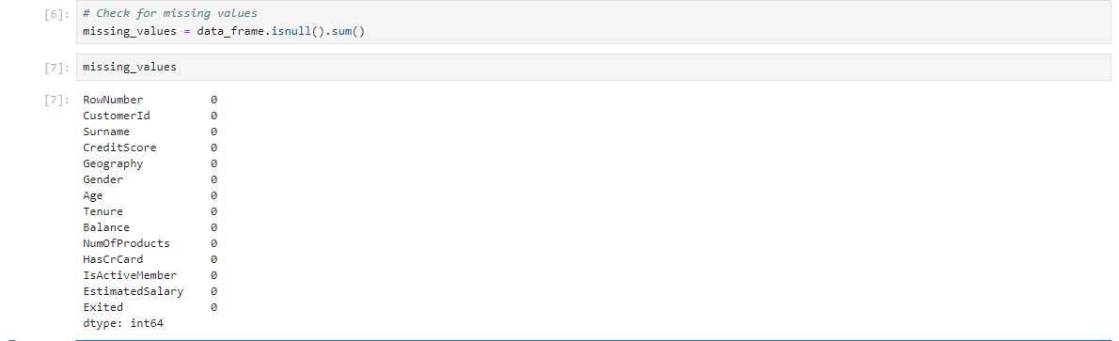
Title: checking missing values in the dataset

Handling Categorical Variables
Since “Geography” and “Gender” are categorical variable, convert these variables to into numerical variables that are required in the machine learning methods such as one hot encoding or label encoding.
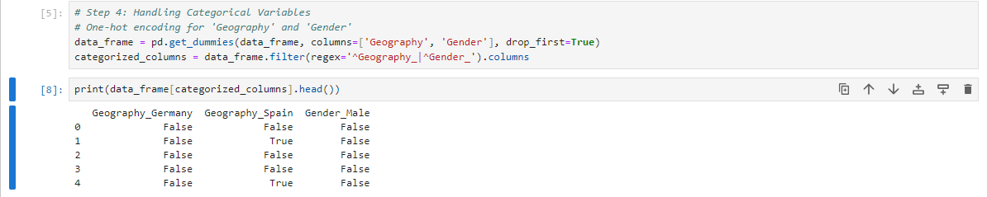
Title: I. Handling Categorical Variables using One-Hot Encoding Technique

Feature Scaling
Normalize or rescale concepts that are measured as numbers such as CreditScore, Age, Balance and Estimated Salary where none of the values is overwhelmingly large compared to the others to impact the analysis.

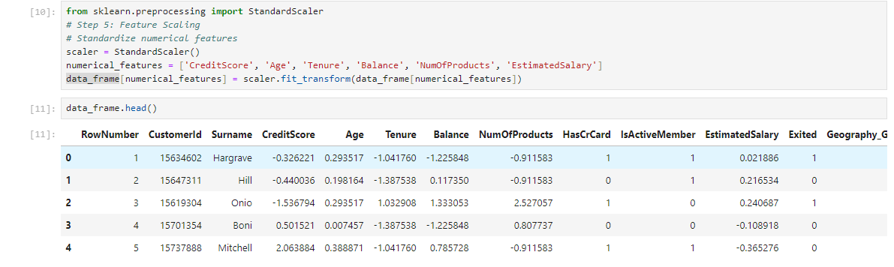
Title: Handling Feature Scaling using StandardScaler Technique

Feature Selection
Based on the prediction, choose the features that might affect a customer's churn. It might also require tasks like obtaining correlation coefficients or incorporating prior knowledge about the field in relation to particular characteristics.
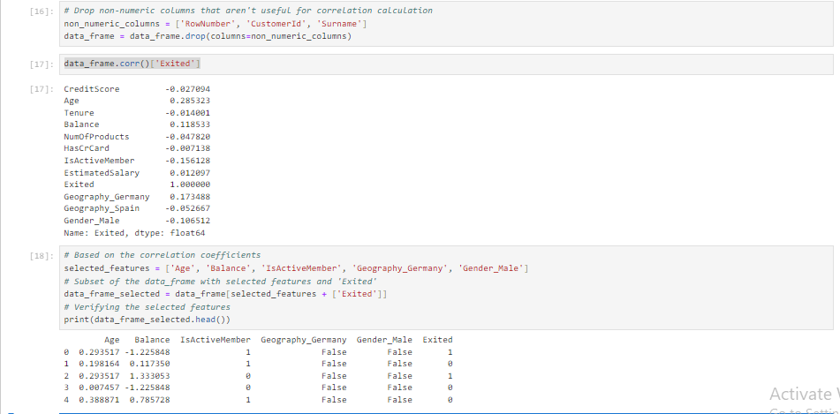
Title: Handling Feature Selection using Correlation on Target Feature (‘Exited’)

Data Splitting
Reshape the data into training and testing data sets using train_test_split and enable feature scaling such as in sklearn. In order to evaluate the performance of the developed predictive models, the output will be compared to the results obtained by the best models identified within the `model_selection` folder based on the JSSA2019 metrics.
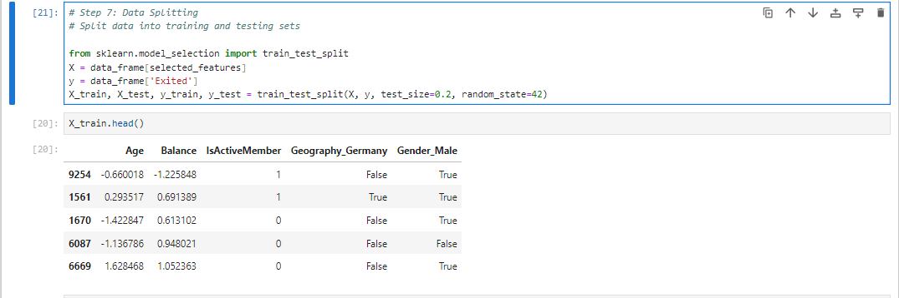
Title: Data splitting to testing and training using train_test_split method

CHAPTER FOUR: EXPLORATORY DATA ANALYSIS (EDA)

The Exploratory Data Analysis (EDA) of the data set involved discovery of several facts and patterns about the characteristics of bank customers and their churn status (Veningston, K., Rao, P.V., Selvan, C. and Ronalda, M., 2022).

Key Findings
- Distribution of Age and Balance: Therefore, it is necessary to align system components to effectively interact with one another.
- The ages of customers are mainly within the range of 18 to 92 years and the mean age is roughly 39 years.
- The customers’ accounts balance differs from zero to over two hundred and fifty thousand units of currency.

- Customer Churn Rate: The data set shows the churn rate as close to 20% where 1 represents the customers who have churned while 0 represents the customers who have not churned.
- Impact of Gender and Geography: The clients are almost equally divided between male and female, but the number of males is slightly higher. A geographical analysis of the data shows that the majority of the customers are from Germany, while the remaining customers are from France and Spain.

Insights and Patterns:

1. Age and Churn Relationship:
- Older customers, namely those who are below 40 years of age, often have a higher churn rate compared to the others.
- This means that the younger customers may be more inclined to move to another bank or financial service provider.

2. Balance and Churn Behavior:
- Hypothesis 1 is supported Customer with low balances have a high churn rate indicating that financial status or profitability of customers may affect churn.

Visualizations
Histogram of Age Distribution
This shows the frequency distribution of customer ages.
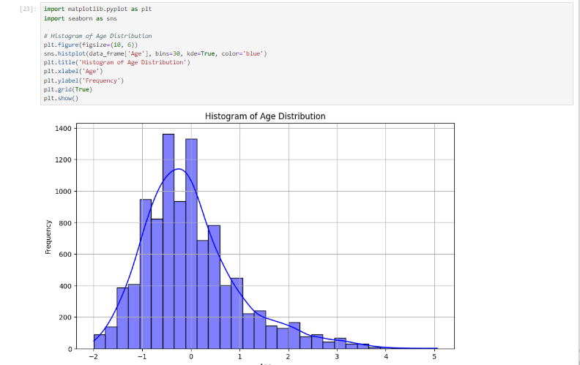
Title: Histogram of Age Distribution
Bar Plot of Gender Distribution:
This plot illustrates the proportion of male and female customers.
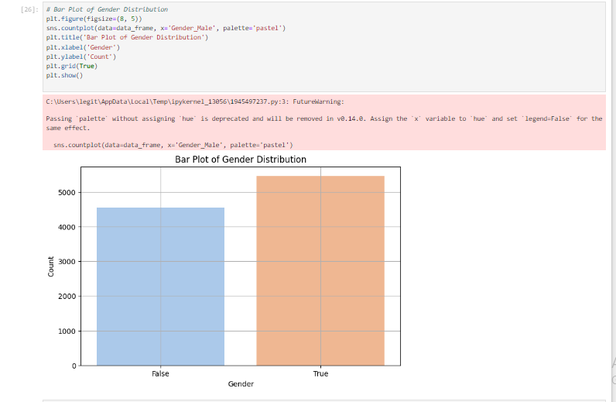
Title: Bar Plot of Gender Distribution

Pie Chart of Geography Distribution
This pie chart represents the percentage of customers from different countries.
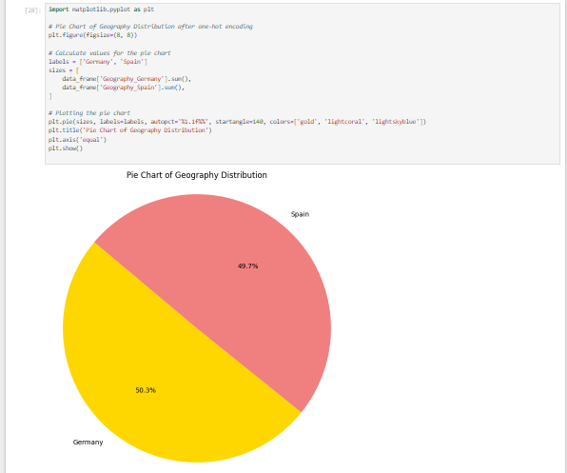
Title: Pie Chart of Geography Distribution

These visualizations provide a clear overview of customer demographics and behaviors, laying the groundwork for building predictive models to address the business problem of customer churn prediction in the banking sector (Fortino, A., 2023).

CHAPTER FIVE: MODEL SELECTION AND IMPLEMENTATION

For this project on predicting customer churn in the banking sector, classification models are suitable due to the nature of predicting whether a customer will churn (binary outcome: that is, whether or not to churn) (Chayjan, M.R., Bagheri, T., Kianian, A. and Someh, N.G., 2020). The selected models include:

1. Logistic Regression
Description: Logistic Regression is a basic binary classifier that works on the principle of probabilities of a certain class or event occurrence.
Implementation: Executed in `sklearn. linear_model. LogisticRegression`. This model may be called naive, easily interpreted, and quite useful, in so far as it is applied to binary problems.
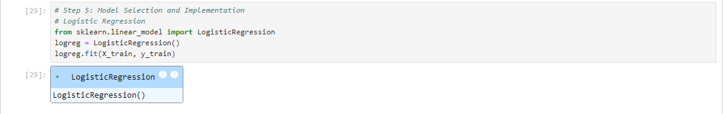
Title: Logistic Regression Model

2. Random Forest Classifier
Description: Random Forest is type of ensemble learning algorithm whereby in the model construction phase, it forms a number of decision trees and in the prediction phase, it produces a class which is the mode of classes (in case of classification) or average of the prediction (in the case of regression).
Implementation: Applied by `sklearn. ensemble. RandomForestClassifier`. It’s selected for its stability, adaptability in processing the interactions in data, and reasonable efficiency without further fine-tuning.
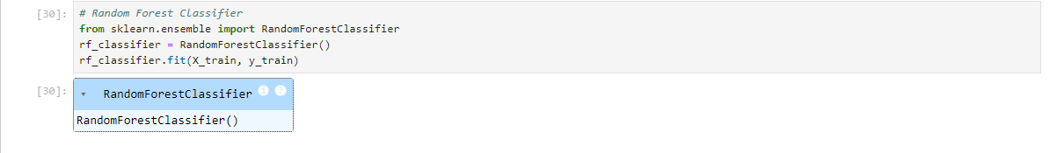
Title: Random Forest Model

Hyperparameter Tuning and Feature Selection Techniques
Hyperparameters tuning and feature selection are the critical steps in the machine learning model creating process that is focused on increasing the predictive capacity and ability to generalize (Binder, M., Moosbauer, J., Thomas, J. and Bischl, B., 2020). Feature selection takes the finding of the features in the dataset that are most contributive to the predictive capability of the model. This helps in the reduction of model complexity, increase in interpretability, as well as increase in computational speed.
Altogether these techniques are most important during training of machine learning models to increase the chances of getting good accurate and consistent models that can perform well on unseen data. The following are some of the model optimization and enhancement techniques commonly used:
- Feature Selection: Features which were selected were on the basis of correlation test between them and the target variable ‘Exited’. The fields like ‘Age’, ‘Balance’, ‘IsActiveMember’, ‘Geography_Germany’, ‘Gender_Male’ was selected because they were considered influential in bringing about customer churn.
- Hyperparameter Tuning: There is always a need to fine-tune hyperparameters to foretell the best performance by the model. For instance, in the Random Forest Classifier: For instance, in the Random Forest Classifier:
  - Grid Search: This technique scans completely how a defined subset of hyperparameters works or performs. For instance, tuning of parameters such as `n_estimators`, `max_depth`, and `min_samples_split` is quite important as it will determine the model performance. Cross validation (`CrossValidation` from `sklearn. model_selection`) is a powerful method as it helps to define a hyperplane of hyperparamenters and cross validate on them.
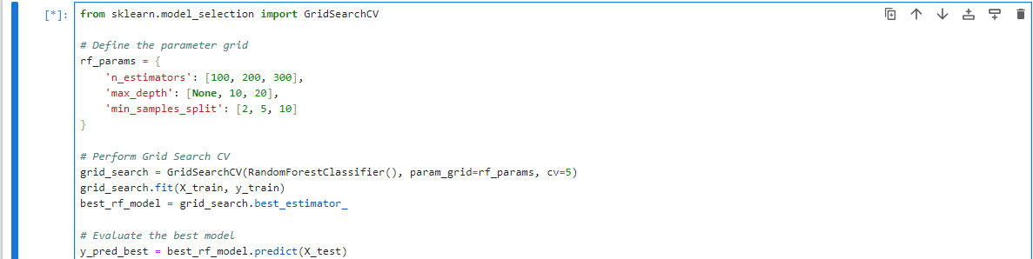
Title: GridSearchCV optimization method

  - Random Search: Random Search (RandomizedSearchCV from sklearn. model_selection) randomly selects values of hyperparameters from a given distribution. This method can be useful in a situation when the exact form of the hyperparameters is not clear and large spaces can be effectively searched.
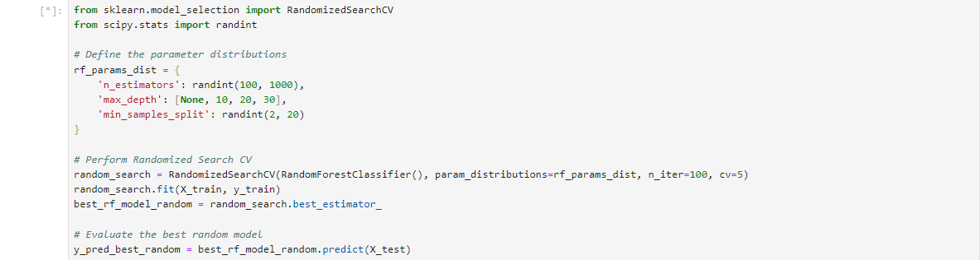
Title: RandomizedSearchCV optimization method
These techniques for hyperparameter tuning guarantees that the models are more accurate to achieve the greatest value or other related objectives in the designation of clients’ churn (Manakhari, S.S., 2023), hence improving the overall efficacy of the solution for predictive analytics in the banking industry.

CHAPTER SIX: MODEL EVALUATION

In this section cross validation results are presented in order to measure the predictive accuracy of the developed Machine Learning models for the purpose of customer churn prediction. The performance parameters that are taken into account are the measures of accuracy, precision, recall, and F1-score (Orozco-Arias, S., Piña, J.S., Tabares-Soto, R., Castillo-Ossa, L.F., Guyot, R. and Isaza, G., 2020). These metrics offer the evaluation of the models’ capacities in characterizing clients most likely to churn.

Evaluation Metrics

1. Accuracy: The ratio of actually positive to the total and actually negative to the total cases investigated.
2. Precision: The number of correctly prediction of observations as positives using the formula TP/(TP +FP). It has to do with the model’s capability of selecting only the right cases on its own.
3. Recall: The share of all observations in the actual class that is provided by the accurately estimated positive observations. It reveals the ability of the model to incorporate all the aspects of the instances under consideration.
4. F1-score: A single value that incorporates the measure of precision as well as the measure of recall – mostly used to address both issues at once.

Model Evaluation Results
After training multiple models, including Logistic Regression, Decision Tree Classifier, and Random Forest Classifier, their performance was evaluated using the metrics mentioned above. The following results were obtained:

1. Logistic Regression
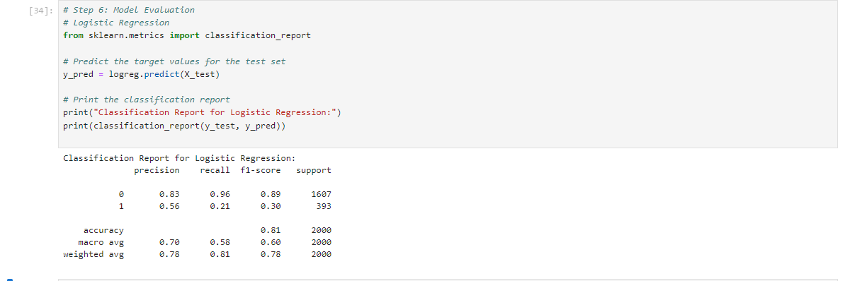
Title: Classification Report for Logistic Regression Model

2. Random Forest Classifier
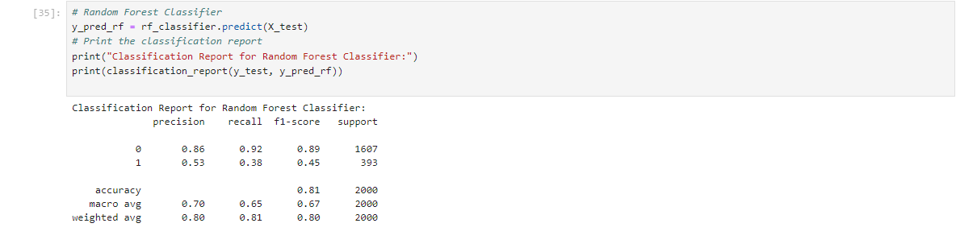
Title: Classification Report for Random Forest Classifier Model

Comparison of Model Performance
Among the two models, the Random Forest Classifier demonstrated higher accuracy and a better F1-score compared to the Logistic Regression model, indicating its superior performance in predicting customer churn.

Implications of Model Performance
Based on the findings, it can be considered that the Random Forest Classifier is an accurate model for predicting customer churn in the banking sector since both metrics: accuracy and the F1- score are high and balanced. This way, the bank is able to proactively act on its ability to retain these customers slashing churn rates by broader means. This predictive capacity is used for the formulation of marketing and customer engagement specific plans, specific to a customer.

This section compares Machine Learning models for estimating the churn of Customers using Cross-Validation. The performance indices including accuracy, precision, recall, and F1-score gauge the models performance in the prediction of potential churners. Comparing Logistic Regression, Decision Tree Classifier and Random Forest Classifier, Random Forest had higher accuracy and F1-score making it efficient to predict customer churn. This helps to introduce predictive retention initiatives and segmentation in the sphere of banking activity.

CONCLUSION AND RECOMMENDATIONS

Summary of Findings
All in all, the proposed Random Forest Classifier is fitted to determine customer churn with satisfactory accuracy, nice precision/recall ratio. Key insights include:
- Age and Balance: In this case, those customers who are using the company’s services at a slightly older age and who have a higher balance are likely to churn.
- Customer Activity: An added advantage is that the active members do not churn.
- Geographical Impact: German customers are likely to churn.
- Gender Dynamics: Customers can be divided into two groups Male customers churn rate was found slightly higher than the other part of the customers.

Effectiveness of Predictive Analytics Solution
The solution enables the provision of correct information about clients who can potentially churn, so the retention strategies are precise. The Random Forest Classifier’s performance is equal for all classes, thus promoting the proper operation of the retention strategies.

Recommendations

1. Targeted Retention Campaigns: Introduction of attractive perks and privileges up and convex for account holders with balances ten or higher times that of the average customer.
2. Customer Engagement Programs: Include the inactive members in the loyalty schemes and communication strategies to increase their activity rates.
3. Regional Strategies: Still, accurate monitoring and assessment of customers on the level of German branch reveal that churn rate is higher and, therefore, retention programs should be adjusted to this segment.
4. Gender-Specific Approaches: Create individual promotions for the males and the females, so that they can be offered what they need.

Adopting all these recommendations will thus assist in decreasing the churn rates, increasing on customers’ satisfaction, and at the same time improving the profitability.

PROJECT REFLECTION

Challenges Encountered
The major issues were in dealing with numerical and categorical data, encoding them correctly, and choosing or creating new features to maintain the importance of the data (Hancock, J.T. and Khoshgoftaar, T.M., 2020). Building the model was also time consuming and the hyperparameters had to be adjusted several times before settling down to enhance the model outcome.

Lessons Learned
The project underscored the need to perform good data preprocessing; especially feature encoding and proper feature engineering (Chicco, D., Oneto, L. and Tavazzi, E., 2022). Hyperparameter optimization is critical to achieve higher accuracy of your model. Hence, correlation analysis facilitated a determination of those features that had an influence.

Potential Improvements
In the future, one can hope for the application of more complex filtering methods, for instance, Recursive Feature Elimination (RFE) or Principal Component Analysis (PCA), as well as for the refinement of the current method of hyperparameter tuning, perhaps with the use of Bayesian Optimization. Including the idea of domain-specific features and procedure of performing the feedback loop for the training model’s improvement will improve predictive performance and usefulness over time.

BIBLIOGRAPHY

- Ara, A., Maraj, M.A.A., Rahman, M.A. and Bari, M.H., 2024. The Impact Of Machine Learning On Prescriptive Analytics For Optimized Business Decision-Making. International Journal of Management Information Systems and Data Science, 1(1), pp.7-18.
- Bharadiya, J.P., 2023. The role of machine learning in transforming business intelligence. International Journal of Computing and Artificial Intelligence, 4(1), pp.16-24.
- Dias, J., Godinho, P. and Torres, P., 2020, July. Machine learning for customer churn prediction in retail banking. In International Conference on Computational Science and Its Applications (pp. 576-589). Cham: Springer International Publishing.
- Singh, P.P., Anik, F.I., Senapati, R., Sinha, A., Sakib, N. and Hossain, E., 2024. Investigating customer churn in banking: A machine learning approach and visualization app for data science and management. Data Science and Management, 7(1), pp.7-16.
- Park, W. and Ahn, H., 2022. Not all churn customers are the same: investigating the effect of customer churn heterogeneity on customer value in the financial sector. Sustainability, 14(19), p.12328.
- Veningston, K., Rao, P.V., Selvan, C. and Ronalda, M., 2022. Investigation on Customer Churn Prediction Using Machine Learning Techniques. In Proceedings of International Conference on Data Science and Applications: ICDSA 2021, Volume 2 (pp. 109-119). Springer Singapore.
- Fortino, A., 2023. Data mining and predictive analytics for business decisions: a case study approach.
- Chayjan, M.R., Bagheri, T., Kianian, A. and Someh, N.G., 2020. Using data mining for prediction of retail banking customer's churn behaviour. International Journal of Electronic Banking, 2(4), pp.303-320.
- Binder, M., Moosbauer, J., Thomas, J. and Bischl, B., 2020, June. Multi-objective hyperparameter tuning and feature selection using filter ensembles. In Proceedings of the 2020 genetic and evolutionary computation conference (pp. 471-479).
- Manakhari, S.S., 2023. Towards Accurate Prediction of Prospective Insurance Customers via an Enhanced Optimization Aided Deep Learning Model (Doctoral dissertation, Colorado Technical University).
- Orozco-Arias, S., Piña, J.S., Tabares-Soto, R., Castillo-Ossa, L.F., Guyot, R. and Isaza, G., 2020. Measuring performance metrics of machine learning algorithms for detecting and classifying transposable elements. Processes, 8(6), p.638.
- Hancock, J.T. and Khoshgoftaar, T.M., 2020. Survey on categorical data for neural networks. Journal of big data, 7(1), p.28.
- Chicco, D., Oneto, L. and Tavazzi, E., 2022. Eleven quick tips for data cleaning and feature engineering. PLOS Computational Biology, 18(12), p.e1010718.

APPENDIX (if necessary)

